**Discover and Book a Coworkingspace**



**Book now!**

The best way to find and book a coworkingspace everywhere

**Explore coworkingspaces**



**San Francisco**

**London**

**New York**

**Premium Coworkingspaces**

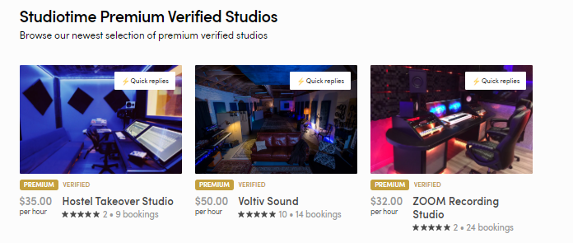

**What are you looking for?**



**Meeting Room**

**Single Desk**

**Flex Desk**

**How it works?**

1. **Discover and choose a Coworkingspace**

**Discover Workspaces nearby or in a few other places worldwide. From the Single Desk to a Meeting Room, book and choose the Office-Space you want. We have the right coworkingspace for every Budget and every requirement**

1. **Request Coworkertime**

**Have you questions about a Coworkingspace, the equipment or others? Use our Messaging Service to stay in touch with the service provider**

1. **Book and Pay**

**Schedule the time and the Date for your Workspace and book and pay with a few clicks.**